Cassini Spacecraft
Last Updated on Thu, 28 Jan 2021 | Cassini
The Galileo spacecraft had incorporated a spin-bearing assembly so that one part of the vehicle could be three-axis stabilised while the remainder rotated like the Pioneers to optimise particles and fields measurements. Spinning communication satellites in geostationary orbit use similar spin bearings to hold their antennas facing the Earth. However, it was decided not to utilise such a complex mechanism on Cassini, therefore the spacecraft will have to stabilise itself to perform aimed observations and spin for particles and fields sensing. It will spend most of the time with its high-gain antenna aimed at the Earth for ideal communications. Galileo (like the Voyagers) had a scan platform to enable its aimed instruments to track a target during a fly-by without the vehicle needing to manoeuvre. Unfortunately, financial constraints forced the deletion of Cassini's scan platform (indeed, at one time it was to have two such platforms). With its instruments bolted onto its framework, Cassini will have to turn towards a target to make observations. Since its high-gain antenna will not be able to be held facing the Earth at such times, the spacecraft will have to 'buffer' the data from its instruments until their observations are complete, then turn its high-gain antenna back towards Earth for downloading.
The integrated propulsion system built by Lockheed-Martin incorporates a pair of redundant 445-newton engines that will make the major manoeuvres such as the Saturn Orbit Insertion and later periapsis-raising burns, and four 'quads' of thrusters to control the spacecraft's orientation. The bi-propellant system burns hydrazine in nitrogen tetroxide. Because these reactants are hypergolic, the engine does not need an 'igniter'. The redundant engines are mounted side-by-side, and the engine that fires must be aimed to ensure that its thrust is directed through the vehicle's centre of mass. The JPL-developed engine gimbal actuators that fine-tune the alignment of the main engine to compensate for the randomly shifting propellant were derived from those of the Viking orbiters.
Cassini has a system of gyroscopic reaction wheels with which to stabilise itself and make small attitude changes without firing its thrusters. Three of the quartet of wheels are mounted orthogonally to one another, one in each of the Cartesian axes; the fourth wheel is in standby, as a spare. Each wheel is driven by an electric motor. As a result of Isaac Newton's famous law that every action imparts an equal and opposite reaction, changing the rate at which a wheel rotates applies a torque to the spacecraft and causes it to rotate in space around the appropriate axis. The reaction wheels will serve as the primary attitude control system for normal operations. The
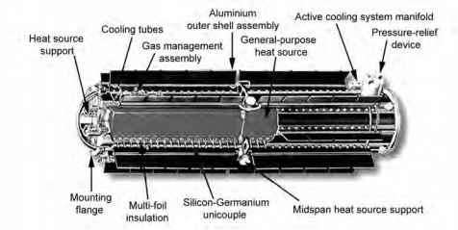
The structure of the Radioisotope Thermo-electric Generator (RTG).
primary source of inertial reference is a star tracker. Between star fixes Cassini will monitor its attitude employing gyroscopes.
Cassini is powered from a trio of RTGs, mounted singly around the base of the propulsion system. Each RTG has 18 iridium-clad high-strength carbon composite modules, each of which contains a pair of golf-ball-sized spheres of plutonium-238 dioxide in dense ceramic form. Plutonium dioxide is also present in 117 radioisotope heater units situated to keep the electronics systems on Cassini and Huygens at their operating temperatures. Plutonium-238 is a non-fissile alpha-emitting isotope having a half-life of 88 years. As the power output falls in line with the expenditure of radioactive isotope, Cassini's power supply will slide from 815 watts at the beginning of the mission to 638 watts at the conclusion of the four-year primary mission in the Saturnian system. In total, there are 32 kilograms of radioactive material. The units were built by General Electric. The Power and Pyro Subsystem (PPS) regulates the 30-volt supply, and distributes it to the core systems and instrumentation through 10 kilometres of cabling.
The 4-metre-diameter solid dish-shaped high-gain antenna is affixed to the 'front' of the vehicle - opposite the propulsion system. It was supplied by Alenia Spazio in Italy. The 20-watt X-Band transmitter can vary its rate between 20 bits and 169 kilobits per second. A low-gain antenna is mounted on the end of the tower in the dish's centre, and another projects from the body of the vehicle, beneath the Probe Support Equipment, so Cassini will be able to communicate irrespective of its orientation, although at a much lower bit-rate when on these other antennas. Whereas Galileo had a reel-to-reel tape recorder for storage of data being buffered for transmission to Earth, it was decided that Cassini should utilise a 3.6-gigabit solid-state memory subsystem instead. The wisdom of this decision was reinforced when Galileo's recorder developed a fault shortly before the spacecraft entered the Jovian system. Although the radiation in the Saturnian magnetosphere is less intense than Galileo had to endure in close to Jupiter, Cassini's solid-state memory has nevertheless been heavily shielded in order to protect it from the kind of random damage suffered by the computer memories on board Galileo.
Instrumentation
Cassini has 335 kilograms of scientific instruments, divided between aimed remote-sensing and particles and fields studies.

Aimed imaging systems
Cassini has four optical remote-sensing instruments, collectively operating from the ultraviolet to the far-infrared, together with a radio-frequency imaging radar. There is always a trade-off in optical instrumentation between high spatial and spectral resolution. Whereas the main imaging system has high spatial resolution and a number of broad filters in specifically selected spectral bands, the spectrometers emphasise spectral resolution at the expense of spatial resolution, so these are more accurately described as 'mappers' than 'imagers'.
The Imaging Science System (ISS) is a high-spatial-resolution imaging system. In effect, it is Cassini's 'eye'. It comprises two subsystems, each with a 1,024 x 1,024
178 Cassini-Huygens
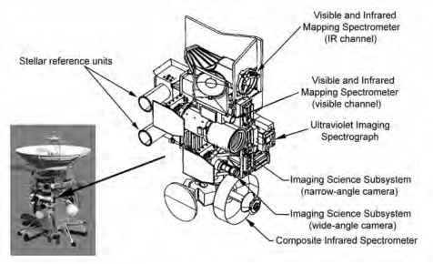
Cassini's Remote Sensing Pallet.
pixel array CCD camera. Although referred to as 'wide angle', the 200-millimetre-focal-length f/3.5 refractor yields a square image that spans only 3.5 x 3.5 degrees, so by any popular measure it is actually a telephoto. The 'narrow angle' camera uses a 2,000-millimetre-focal-length f/10.5 folded-optics reflecting telescope with a field of view that is ten times narrower. The hardware was supplied by JPL, but C.C. Porco of the University of Arizona is the principal investigator for imaging science.
The spectral range of the CCD detector is much broader than the vidicon tube of the Voyager's system, extending shortward into the ultraviolet and longward into the near-infrared. The wide-angle camera is sensitive from 0.38 to 1.1 microns, and the narrow-angle camera extends this shortward to 0.2 micron. Each camera has a wheel with filters for a variety of specific purposes. The wide-angle camera is fitted with 18 filters and the narrow-angle camera with 24 filters. CCDs offer other advantages over vidicons. As the dynamic range is greater, the image will not be so readily 'washed out' when an object is subjected to a wide range of illumination. Furthermore, the output of a CCD is 'linear' across its dynamic range, so it is more readily calibrated and will be better suited to photometry measurements for albedo studies. The ISS will map the three-dimensional structures of the atmospheres of Saturn and Titan, determining the composition and distribution of clouds and aerosols and measuring their scattering, absorption and solar heating properties. It will also seek lightning, auroral displays and airglow phenomena. In the case of Titan, the filters for the 0.94- and 1.1-micron 'windows' will enable Cassini to image tropospheric methane clouds and, where the weather is clear, map the reflectivity of the surface at high resolution to complement the topographic data from radar mapping.
The Visual and Infrared Mapping Spectrometer (VIMS) is a improved version of the Galileo spacecraft's Near-Infrared Mapping Spectrometer (NIMS) incorporating a Visual Subsystem covering the range 0.35 to 1.07 microns in 96 channels and an Infrared Subsystem from 0.85 to 5.1 microns in 256 channels. The Visual Subsystem consists of a Shafer telescope, a holographic spectrometer grating, and a silicon CCD area array focal-plane detector. Because it is configured as a 'pushbroom' imager, the instantaneous field of view (IFOV) is an entire line of pixels. This is scanned across the scene with a single-axis scanning mirror to produce a series of contiguous rows, which together produce a two-dimensional image. The Infrared Subsystem employs a Cassegrain telescope, a conventionally ruled spectrometer grating, and a 256-element linear array focal-plane assembly. It is a 'whiskbroom' scanning imager, so the IFOV is a single 32 x 32 milliradian square pixel. A two-dimensional image is assembled by raster scanning along a row of pixels, dropping down a row, scanning that row, etc., utilising a two-axis scanning mirror. The VIMS therefore operates differently to the NIMS. Both of its spectrometers use fixed gratings. The timing is such that the Visual Subsystem integrates as the Infrared Subsystem pixels are being scanned out one-by-one (cross-track) on the same piece of the scene. The Visual Subsystem then steps one slit width (down-track) and the Infrared Subsystem does a fly-back-and-step, after which it scans the next piece of the scene. Thus, both spectrometers can scan a two-dimensional scene using the same pixel scale.4 In contrast, the NIMS employed a single channel and a moving grating, and a scan mirror which nodded up and down in one direction, with the second dimension being built up either by virtue of the relative motion between the spacecraft and the target or by slewing the scan platform. The VIMS has twice the spectral resolution of the NIMS. The sensitivity of the instrument derives from its radiative cooling system. The Infrared Subsystem was supplied by JPL, and the Visual Subsystem by Officine
A diagram of the structure of Cassini's Visual and Infrared Mapping Spectrometer.
Passive Thermal Radiator
Passive Thermal Radiator
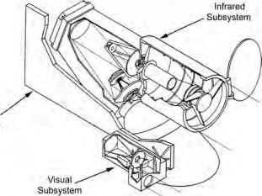
A diagram of the structure of Cassini's Visual and Infrared Mapping Spectrometer.
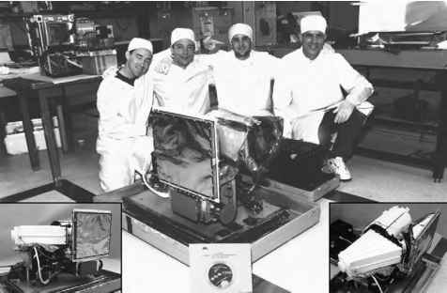
The Visual Subsystem of Cassini's Visual and Infrared Mapping Spectrometer was supplied by Officine Galileo in Italy, and the Infrared Subsystem was built by JPL, where the instrument was integrated by engineers Paul Kirchoff (on the left), Ed Miller (VIMS systems engineer), Michael Brenner and Dave Rosing. (Courtesy of Robert H. Brown of the Departments of Planetary Sciences and Astronomy at the University of Arizona.)
The Visual Subsystem of Cassini's Visual and Infrared Mapping Spectrometer was supplied by Officine Galileo in Italy, and the Infrared Subsystem was built by JPL, where the instrument was integrated by engineers Paul Kirchoff (on the left), Ed Miller (VIMS systems engineer), Michael Brenner and Dave Rosing. (Courtesy of Robert H. Brown of the Departments of Planetary Sciences and Astronomy at the University of Arizona.)
Galileo in Italy. R.H. Brown of the University of Arizona's Lunar and Planetary Laboratory is the overall principal investigator.
By measuring reflected and emitted radiation, the VIMS will be able to determine the composition and temperature of Saturn's atmosphere, charting the temporal behaviour of the surface winds, eddies and other features, and the cycling of the deep atmosphere. It will map the distribution of gases, haze and cloud species in Titan's atmosphere, and observe the surface to search for active cryovolcanism. It will also determine the composition and distribution of materials on the icy satellites and rings.
The Composite Infrared Spectrometer (CIRS) was originally named the Infrared Fourier Spectrometer. It serves the same role as the IRIS used by the Voyagers, but it is more technologically advanced with a new chilled detector providing an order of magnitude improvement in spectral resolution. Its three interferometers are fed by a single 500-millimetre-diameter telescope. As the far-infrared spectrometer senses from 17 microns to 1,000 microns, it detects primarily thermal emission. It has a 4.3-milliradian circular field of view. A pair of mid-infrared spectrometers draw the range shortward to 7 microns. These use 1 x 10 linear array detectors, each element having a 0.273-milliradian square field of view. Thus, despite the trade-off of spatial versus spectral resolution, the spatial resolution of these mid-infrared detectors is 15 times narrower than that of the IRIS, so the CIRS will be able to make a series of measurements along a line that would have been entirely contained within its predecessor's field of view. The great sensitivity of the instrument derives from its radiative cooling system.
The CIRS will measure infrared emission from vibrating molecules in the atmospheres of Saturn and Titan and provide three-dimensional maps of the temperature, clouds and hazes, and chemical composition. Observing on the limb will not only eliminate surface emissions from the field of view, but also optimally investigate the vertical structure. At Voyager 1's fly-by distance, IRIS did not have the resolution to make detailed limb profiles, but Cassini's approach will be much closer and its linear detector array will be able to secure detailed profiles. By repeatedly doing this as the viewing angle changes, it will be able to assemble regional maps, and by looking 'straight down', it will be able to measure the temperature of Titan's surface.5 The CIRS will also measure the amount of energy reflected from, and radiated by, the rings at infrared and millimetre wavelengths to determine the size, composition, texture, shape, and rotation of the constituent particles. Its measurements of the thermal properties and composition of the surfaces of the icy moons will complement such observations by the other remote-sensing instruments. The principal investigator is V.G. Kunde of NASA's Goddard Space Flight Center in Greenbelt, Maryland.
The Ultraviolet Imaging Spectrograph (UVIS) integrates four instruments with a common microprocessor control system.6 Between them, the Far-Ultraviolet Spectrometer (FUV) and the Extreme-Ultraviolet Spectrometer (EUV) span from 55 to 190 nanometres with a resolution of 0.2 to 0.5 nanometre. The High-Speed Photometer (HSP) will trace the light curves of stellar occultations. The Hydrogen Deuterium Absorption Cell (HDAC) will measure the ratio of deuterium to hydrogen. Apart from their grating ruling density, optical coatings and detector details the three spectrometers are similar, having a telescope with a three-position slit changer, a baffle system, and a spectrograph with a microchannel plate detector employing a coded anode converter. Each telescope consists of an off-axis parabolic section with a focal length of 100 millimetres, a 22 x 30 millimetre aperture, and a baffle with a field of view of 3.67 x 0.34 degrees. A mechanism places one of the three entrance slits at the focal plane of the telescope, each corresponding to a different spectral resolution. The HSP measures undispersed light from its own parabolic mirror using a photomultiplier tube detector. The HDAC has a hydrogen cell, a deuterium cell, and a Channel Electron Multiplier (CEM) detector to record photons that are not absorbed in the cells. The resonance absorption cells are filled with pure molecular hydrogen and deuterium, as appropriate, and are located between an objective lens and a detector. Both cells are made of stainless steel coated with teflon and are sealed at each end with magnesium fluoride (MgF2) windows.7
By observing stars as they are occulted by the limbs of Saturn or Titan, the UVIS will provide thermal and compositional profiles of the thermosphere to complement those by the CIRS more deeply within the atmospheres. It will be able to monitor the auroral displays that form as solar wind particles flood into the magnetosphere and
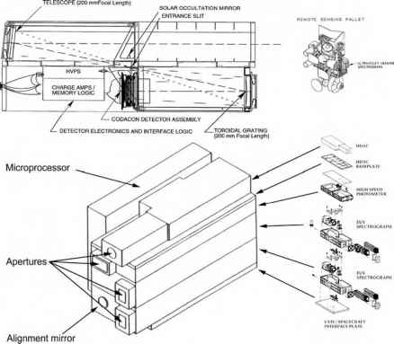
Cassini's Ultraviolet Imaging Spectrograph. (Courtesy of lone Caley, administrative assistant to L.W. Esposito of the Laboratory for Atmospheric and Space Physics at the University of Colorado.)
excite the ionosphere, and correlate the diurnal variations of the charged particles with the state of the magnetosphere and the solar wind. It should also be able to detect any exospheres of the icy satellites comprising species sputtered from the surface by the charged particles in the magnetospheric wind. The photometer's light curves of stars that the spacecraft sees passing behind Saturn's ring system will yield profiles of the distribution of ring material.8 The principal investigator is L.W. Esposito of the Laboratory for Atmospheric and Space Physics of the University of Colorado at Boulder.
The Italian Space Agency provided Cassini's sophisticated telecommunications system, which has been designed to double as the Titan Radar Mapper (RADAR). In this role, it will utilise the five-beam feed assembly of the spacecraft's high-gain antenna as a 'synthetic aperture' radar. Once the spacecraft has oriented itself to aim its antenna at Titan, it will transmit a radar pulse and then monitor how the energy is reflected by the surface. It will operate for approximately an hour before closest approach. On a typical fly-by with a minimum altitude of 1,000 kilometres, the spatial resolution will vary between 0.35 and 1.7 kilometres along the imaging strip. A short wavelength has been selected to document the surface relief accurately, so it will not be able to penetrate water ice to 'sound' the subsurface. A radar altimeter will determine the mean elevation of each sample point to within 90 to 150 metres vertical resolution. Varying incidence angle and polarisation will allow simultaneous retrieval of the temperature and dielectric constant of the surface, and thereby yield compositional information. Although the radiometer's sample spot will span at least 7 kilometres, this will facilitate thermal mapping. Michael Janssen of JPL is leading the radiometer project. The radar data will be stored until Cassini can reorient itself to turn the dish towards the Earth. The Magellan spacecraft used a similar mode of operation, with its high-gain antenna doubling as a radar to map Venus through its cloud cover. Magellan's orbital plane was fixed relative to the stars so that the radar produced a series of strips (dubbed 'noodles' since they were long and thin) as the planet rotated on its axis, and these were subsequently integrated into a global map by sophisticated software. By being limited to a series of fly-bys of Titan, the radar strips from Cassini will not overlap, so rather than assemble a global map it will be able to survey only isolated swaths of the surface at high resolution, with lower resolution data providing the context in which to interpret the fine detail. The radar data will characterise the moon's surface by its reflectance, which depends upon composition, slope and degree of roughness. It will be possible to distinguish between compositional and topographic features using the altimeter data. With knowledge of the surface morphology, geologists should finally be able to infer the processes which formed and modified Titan's surface. It should also resolve the question of whether there are fluid hydrocarbons on the surface. Despite its distinctive chemistry, Titan's morphology might turn out to be remarkably familiar. Later, the radar may also be used to study the ring system. Charles Elachi of JPL is the principal investigator for the radar imaging experiment.9
Voyager 1's single fly-by of Titan took six months of detailed planning. Cassini will make 44 Titan fly-bys during its four-year primary mission. ''We have to be many times more efficient at planning the observations,'' noted R.D. Lorenz of the University of Arizona's Lunar and Planetary Laboratory, and a member of the team. ''There is a lot of work in setting up the software and deciding which places to look at. This is a very difficult decision-making process, because there are lots of good instruments on Cassini and you have to think about what you can learn from each observation.'' The plan is to map the entire surface at medium resolution, and at least 25 per cent at high resolution. The initial focus, of course, will be to investigate the site where the Huygens probe sets down.

Particles and fields sensors
Many of the instruments in Cassini's particles and fields suite are technologically updated and functionally enhanced versions of those of the Pioneers, Voyagers and Galileo spacecraft. To an extent, these instruments address general themes, and each provides a particular part of the 'big picture'. When dedicated to particles and fields observations, Cassini will slowly rotate in order to optimise the spatial resolution of its sensors.
The Ion Neutral Mass Spectrometer (INMS) has an 'open' ion source, a 'closed' ion source, a quadropole deflector and lens system, a quadropole mass analyser and a dual detector system. The open ion source produces ions by ionising neutral gases. It includes an ion trap-deflector that forms trapped ions into a beam. This minimises interaction effects between the gas environment and the open source surface as the source directly samples the gaseous species. The closed ion source also makes ions by ionising neutral gases but uses ram density enhancement to make measurements of higher accuracy and sensitivity for the more inert atomic and molecular species than is possible with the open ion source. This is achieved by maintaining a high input flux to an enclosed antechamber and then limiting the gas conductance by the use of an orifice. Ions are directed to the mass analyser from the selected ion source by changing the potentials on a 90-degree quadropole deflector, an electrostatic device which allows both ion sources to be sequentially switched into a common exit lens system. The quadropole mass analyser has four precision-ground hyperbolic rods mounted in a rigid mechanism. The transmitted mass, the resolution, and the ion transmission are controlled by varying the radio-frequency and direct-current electric fields between adjacent rod pairs, while opposite rod pairs are kept at the same potential. The ion dual detector system amplifies and measures the input from the mass analyser using two continuous dynode multipliers. As with most of the particles and fields suite, the INMS senses the spacecraft's immediate environment. Its quadropole mass analyser will measure the distribution of positive ions and neutral species of up to 99 atomic mass units. In several Titan fly-bys, Cassini will pass close enough to sample the moon's thermosphere and investigate its interaction with the planet's magnetosphere or, if the magnetopause is compressed within the moon's orbit, its interaction with the solar wind.10 The principal investigator is Hunter Waite of the University of Michigan.
The Cosmic Dust Analyser (CDA) will directly measure dust and ice particles in interplanetary space and in the Jovian and Saturnian systems. It will measure the physical, chemical and dynamical properties of particulate matter as functions of the range to the Sun, to Jupiter, and to Saturn and its satellites and rings. It consists of a Dust Analyser (DA), a High-Rate Detector (HRD) and an Articulation Mechanism (AM). The DA has a quartet of charge pick-up grids, a hemispherical target, an ion collector, an electron multiplier and associated sensor electronics. The charge pickup grids mounted at the entrance of the sensor collect the initial impact particles. The hemispherical target is divided into a ring-shaped impact ionisation target and a chemical analyser target set in the middle of the ionisation target. The chemical analyser target has an acceleration grid placed 3 millimetres in front of it. The ion collector has a grid that is negatively biased in order to collect the positively charged plasma ions produced at the impact ionisation target. The electron multiplier is located in the centre of the hemispherical ion collector target. It amplifies the signal produced by ions capable of penetrating the ion collector grid. These ions originate from plasma produced by particle impacts either on the impact ionisation target or on the chemical analyser target, and the output signal from the multiplier differs depending upon the target from which the impacts are being measured. The sensor electronics are in an electronics box attached to the DA sensor chassis. Among other components, this has Charge-Sensitive Amplifiers (CSAs) that measure the signals from all of the grids in the DA. The main electronics has amplifiers and transient recorders, a control and timing unit, a microprocessor, a bus interface unit, a power input circuit, a low-voltage converter and a housekeeping unit. All CSA and electron multiplier signals are separately amplified by logarithmic amplifiers, digitised by an analogue-to-digital converter and stored on transient recorders. Only the recorder connected to the pick-up grids runs continuously. All the others are activated only when a signal is detected at a target or the acceleration grid. The control and timing unit stores and decodes the information provided by the microprocessor and produces all timing and synchronisation signals for operating the instrument. The microprocessor samples and collects the buffered data, coordinates the subsystem measurement cycle, controls the operating modes, processes the data according to a programme loaded in its memory, and outputs data to the spacecraft upon request. The housekeeping unit is a data system that multiplexes, digitises and stores information on the instrument current, the low voltages, the high voltages and the temperature measurements. The AM allows the entire package, including the HRDs, the DA, the main electronics, and the AM electronics, to be oriented relative to the spacecraft's coordinate system. The HRDs are two redundant independent sensors. The electronics for the sensors are contained in the HRD electronics box, and each sensor has its own electronics, independent of its partner. The HRD will be operated in two modes: 'normal' and 'calibrate'. In the normal mode, the operational HRD continuously collects dust particle data. In the calibrated mode, a sequence of pulses is issued to the HRD by the In-Flight Calibrator (IFC) to verify the stability of the electronics.
The CDA is similar to instruments sent into deep space aboard the Ulysses and Galileo spacecraft. Its high-rate impact detector and dust analyser will measure the flux of particulate matter in the space through which the spacecraft passes, determining the mass, velocity, flight direction, electric charge and composition of each individual mote. The multi-coincidence detector has a resolution of 10,000 impacts per second. During the interplanetary cruise, the instrument will follow up earlier studies of the material in the asteroid belt and will then monitor the 'streams' of dust in the space beyond. Once in the Saturnian system, it will measure the interactions of particles with the rings, satellites and magnetosphere. This should settle the question of how much material there is in the ring plane beyond the 'A' ring. The principal investigator is Ralf Srama of the Max Planck Institute for Astrophysics in Heidelberg, Germany.
The Cassini Plasma Spectrometer (CAPS) measures the flux of ions as a function of mass per charge, and of ions and electrons as functions of energy per charge in the spacecraft's environment.11,12 It incorporates an Ion Mass Spectrometer (IMS),13,14 an Ion Beam Spectrometer (IBS)15,16 and an Electron Spectrometer (ELS).17,18 As Cassini conducts its orbital tour of the Saturnian system, CAPS will progressively map the planet's magnetic field, investigate the interaction between the solar wind and the magnetosphere, identify the sources and sinks in the ionospheric plasma and study the aurorae. During fly-bys of Titan, CAPS will study how the moon's ionosphere interacts with the planet's magnetosphere, or, when it is exposed to it,
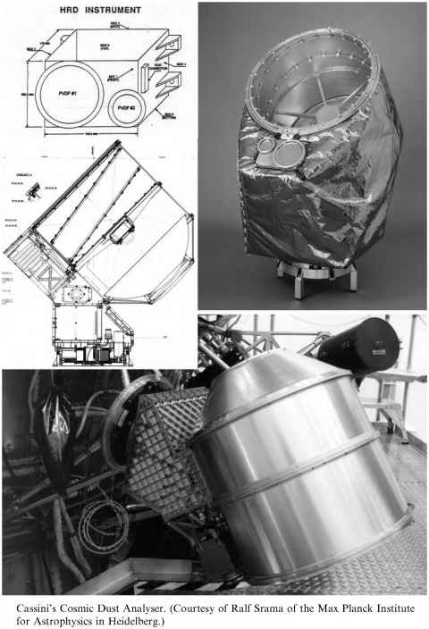
Continue reading here: Hrd Instrument

